5FPS 🡺 Time = 200mSec, 10FPS 🡺 100mSec [Thus 150mSec can be adjusted for capture/compress/transmit/render]

|  |  |  |  |  |  |
| --- | --- | --- | --- | --- | --- |
| **IMAGE** | **Time (mSec)** | **Quality** | **Pellet** | **Type** | **SIZE ?** |
| 162K | 355 | Distorted | 256 | PelleteQuantizer |  |

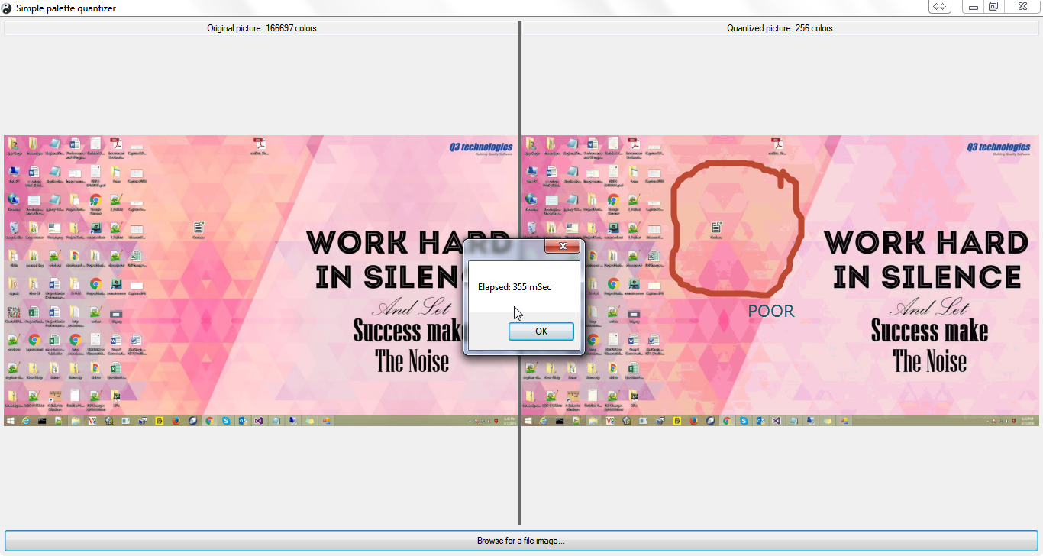

|  |  |  |  |  |  |
| --- | --- | --- | --- | --- | --- |
| **IMAGE** | **Time (mSec)** | **Quality** | **Pellet** | **Type** | **SIZE ?** |
| 82K | 264 | Distorted | 256 | PelleteQuantizer |  |

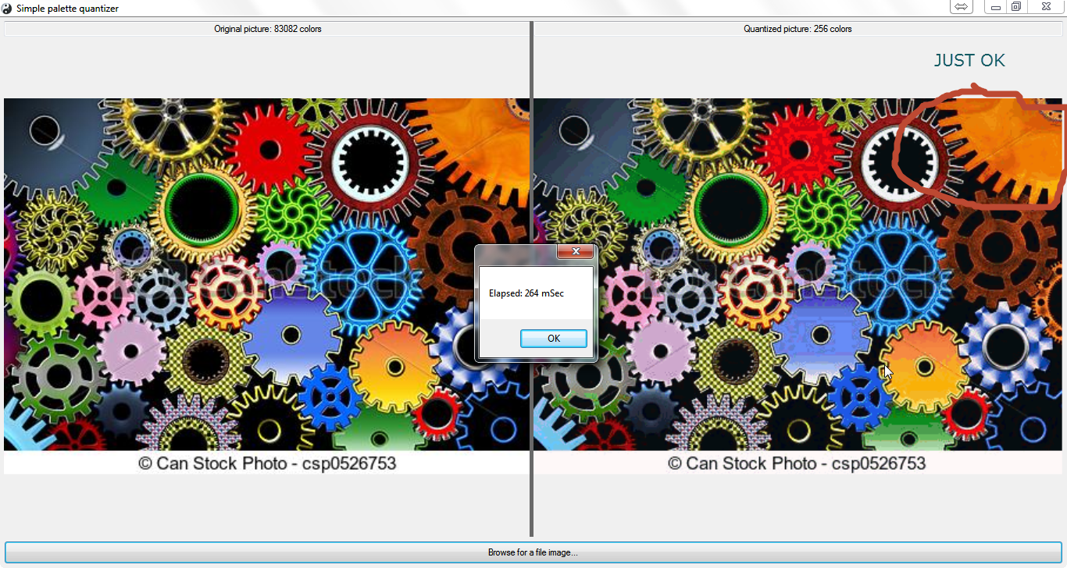

|  |  |  |  |  |  |
| --- | --- | --- | --- | --- | --- |
| **IMAGE** | **Time (mSec)** | **Quality** | **Pellet** | **Type** | **SIZE ?** |
| 415K | 240 | Ok, fine | 256 | PelleteQuantizer |  |

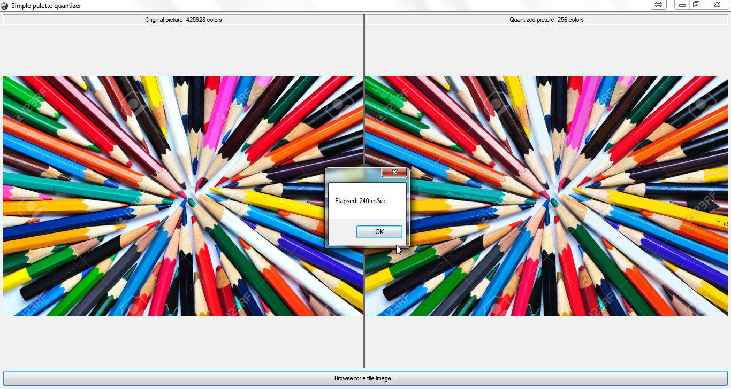

|  |  |  |  |  |  |  |
| --- | --- | --- | --- | --- | --- | --- |
| **SOFTWARE** | **IMAGE** | **Time (mSec)** | **Quality** | **Pellet** | **Type** | **BYTES** |
| V1 | 415K | 2279 | Ok, fine | 256 | Hsb | 522K |
|  | 82K | 473 | So So | 256 | HSB | 91K |
|  | 162K | 2672 | Poor | 256 | HSB | 438K |
|  |  |  |  |  |  |  |
|  |  |  |  |  |  |  |
|  |  |  |  |  |  |  |

^ Popularity is worst quality and time

^ Median is worst in time

^ Octtree is worst in time

^ uniform is fast but worst quality

**TST1**

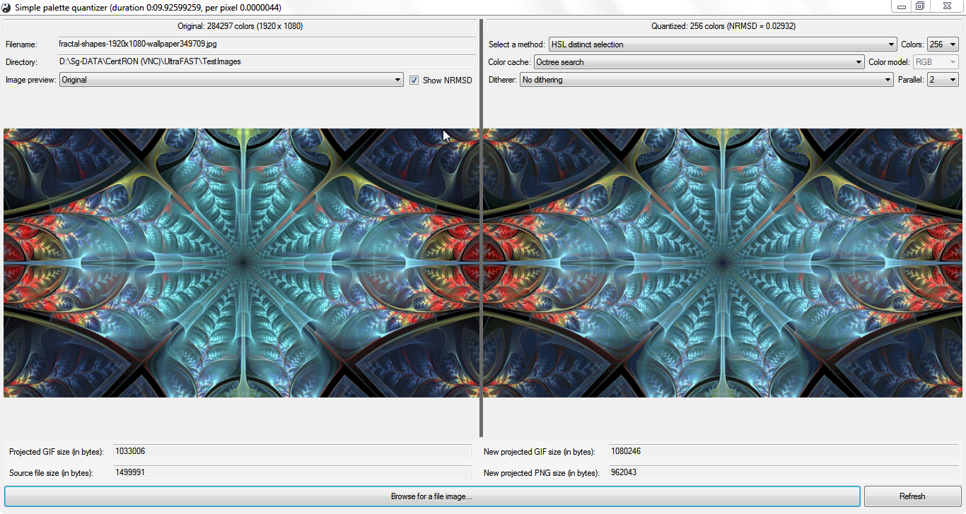

**TST2**

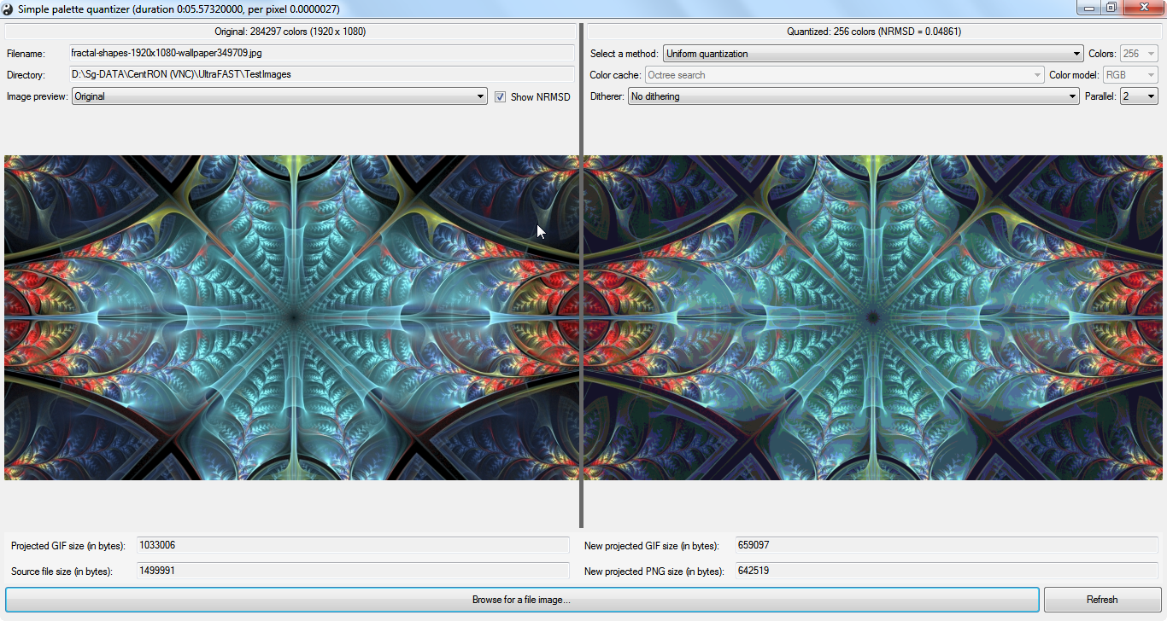

**TST3**

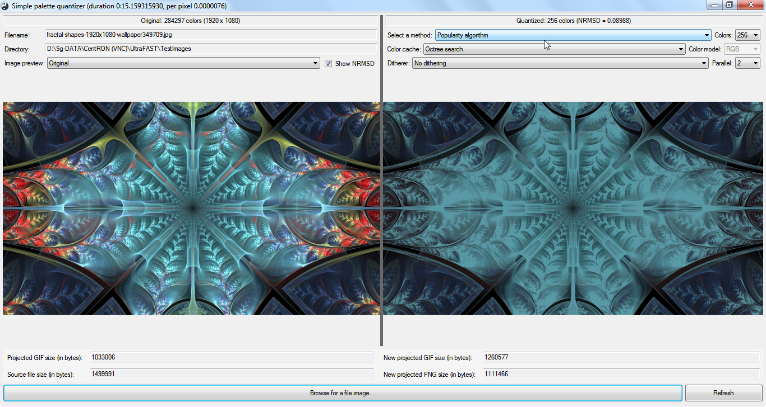

**TST4**

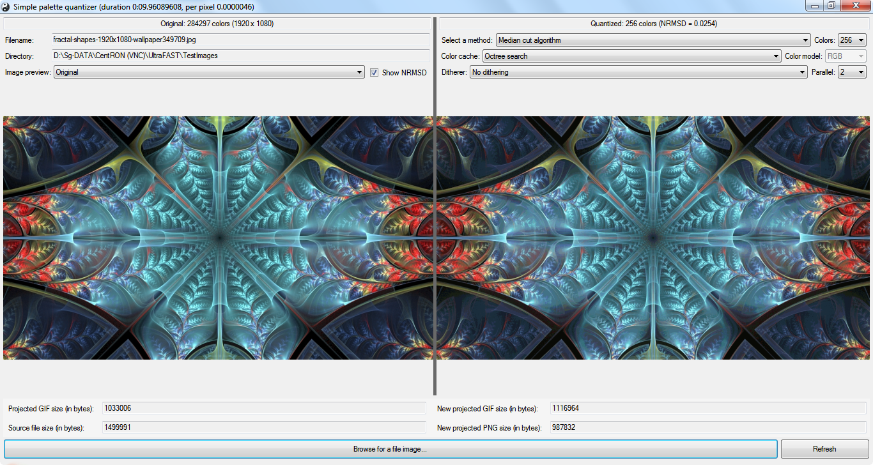

**TST5**

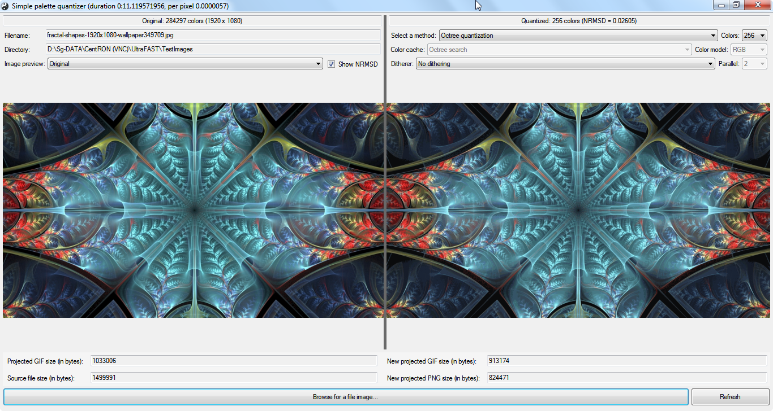

**TST6**

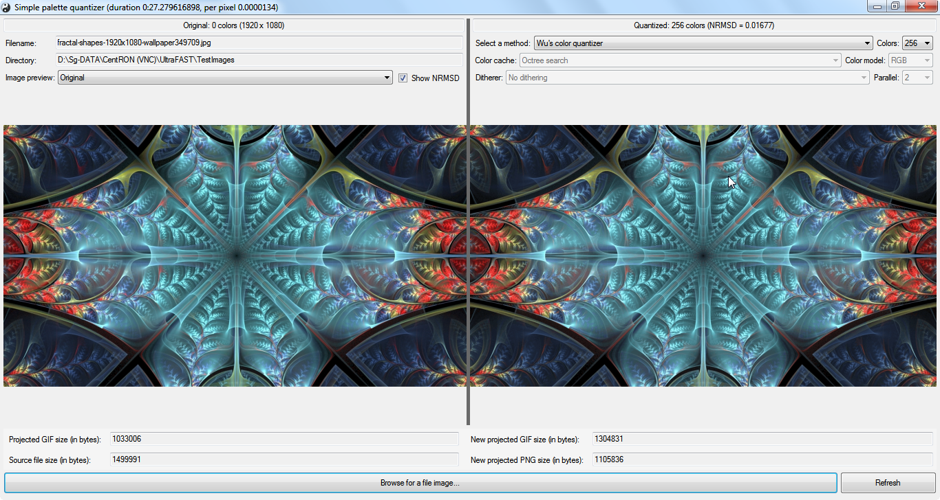

**TST7**

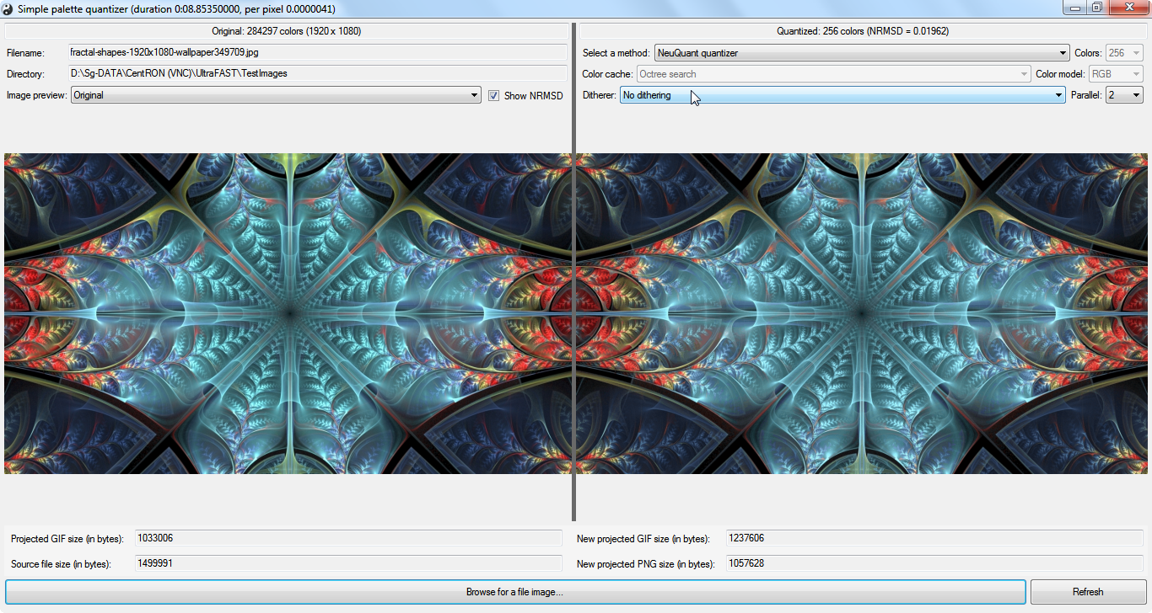

**TST8**

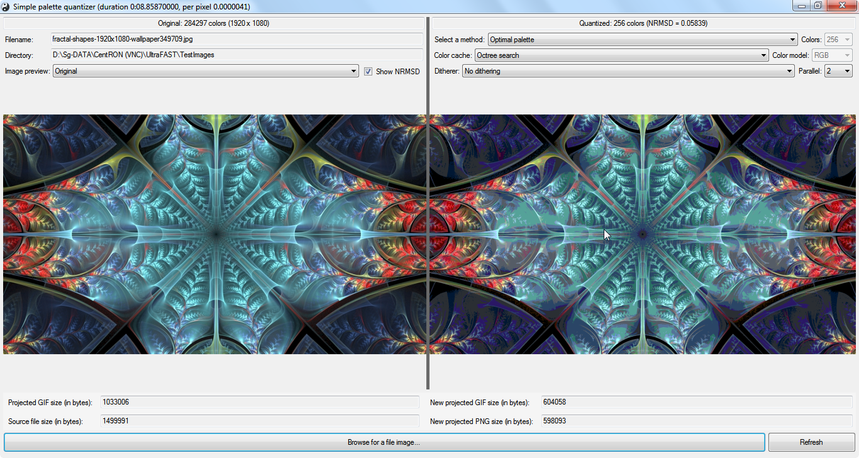

**TST9**

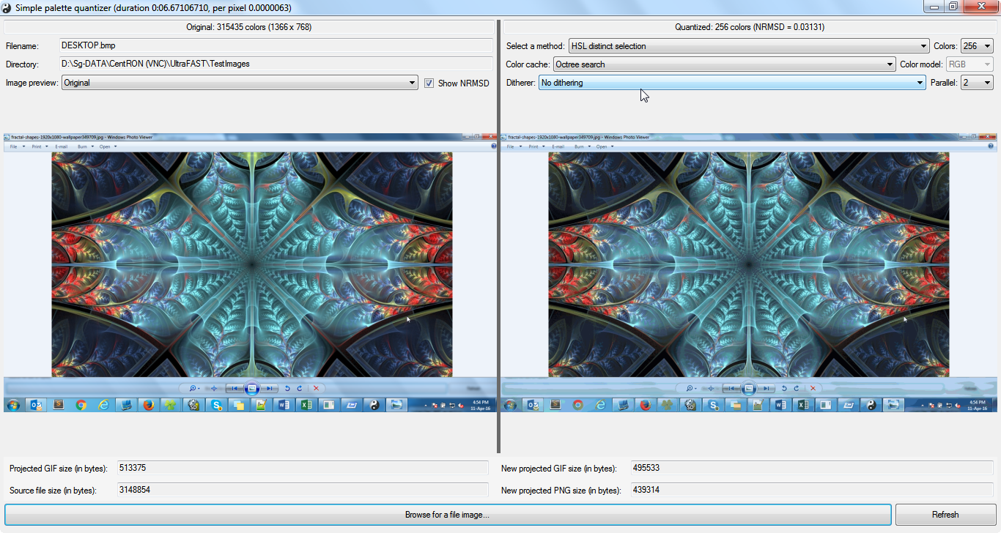

**TST10**

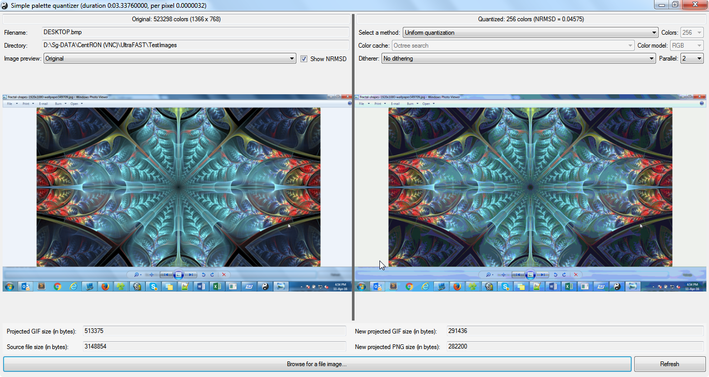

**TST11**

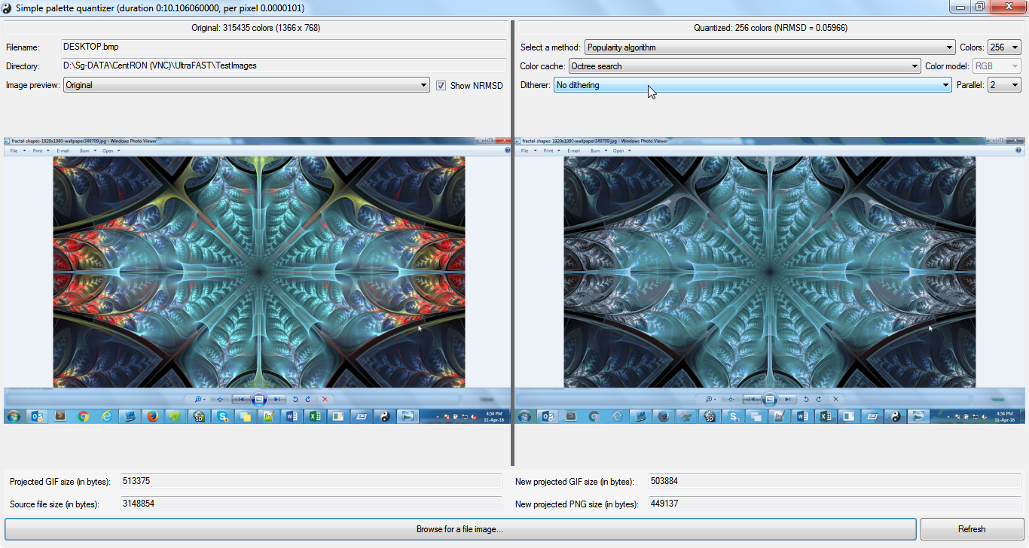

**TST12**

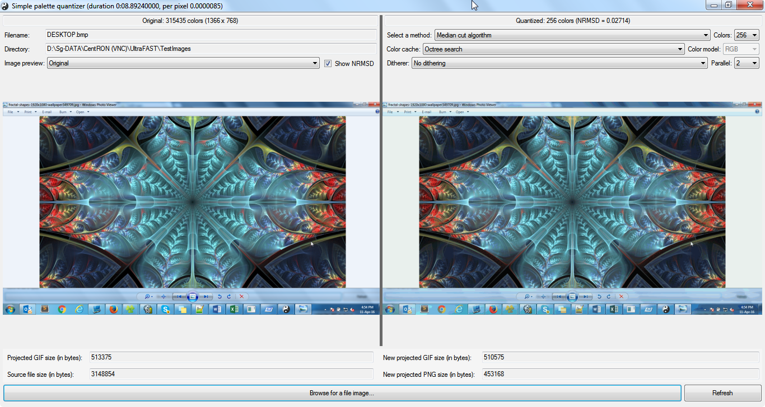

**TST13**

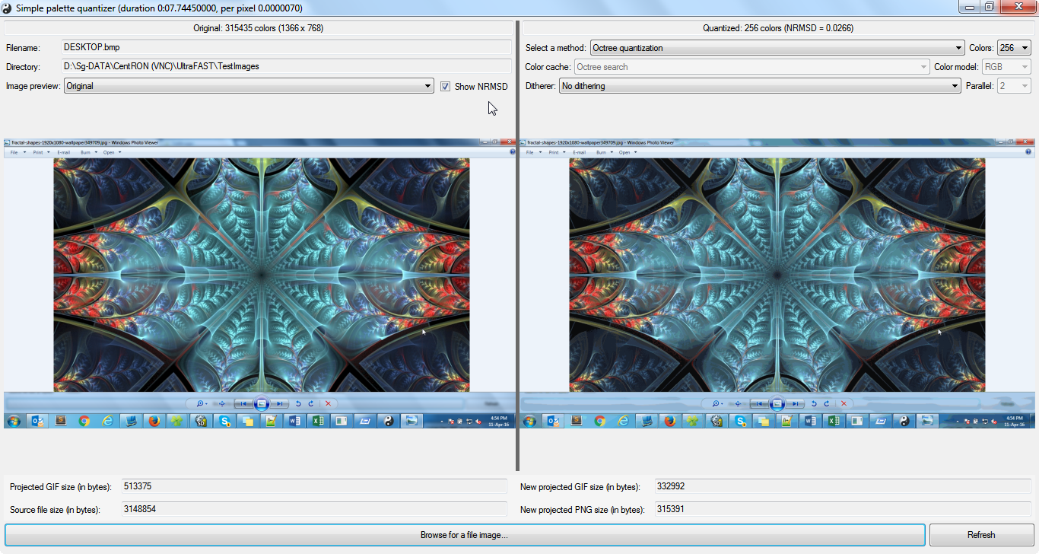

**TST14**

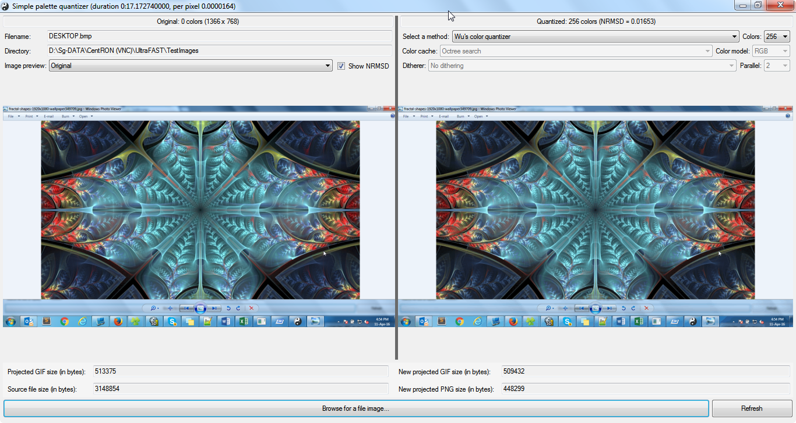

**TST15**

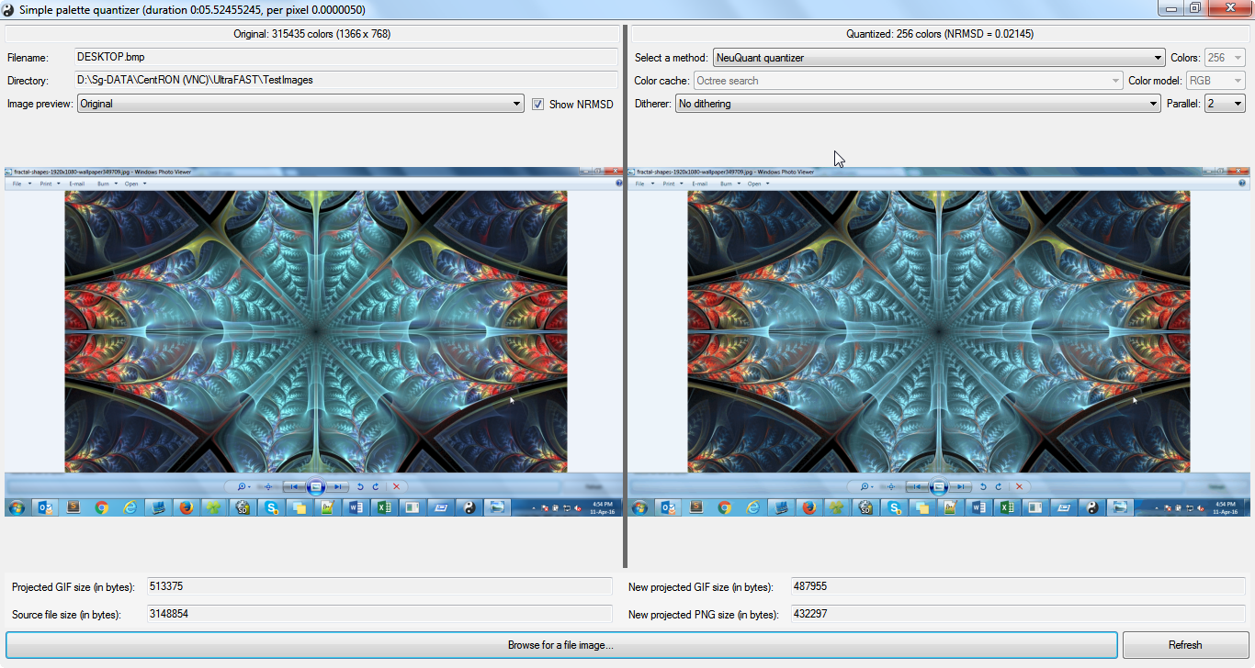

**TST16**

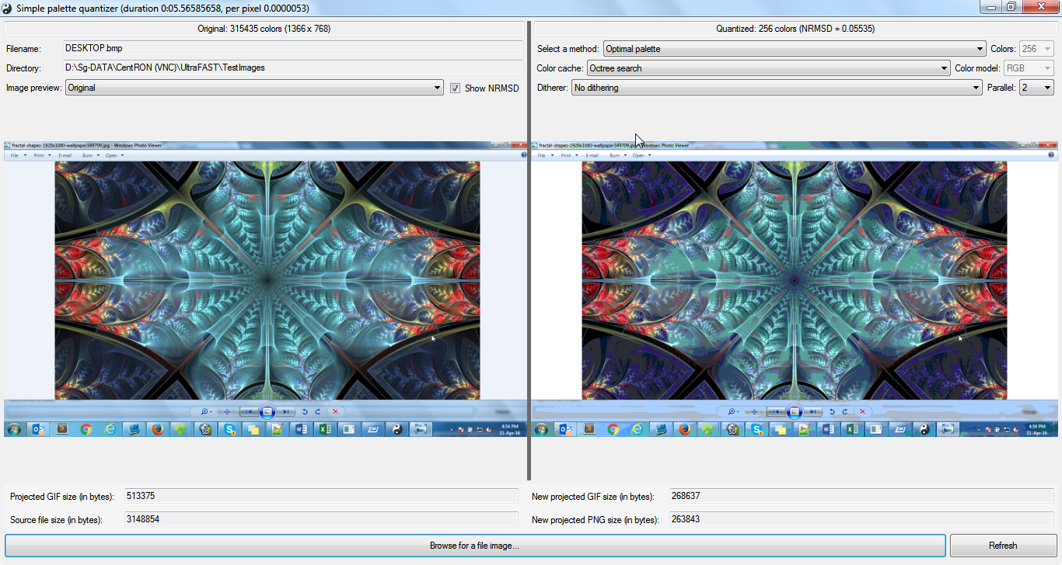

**TST17**

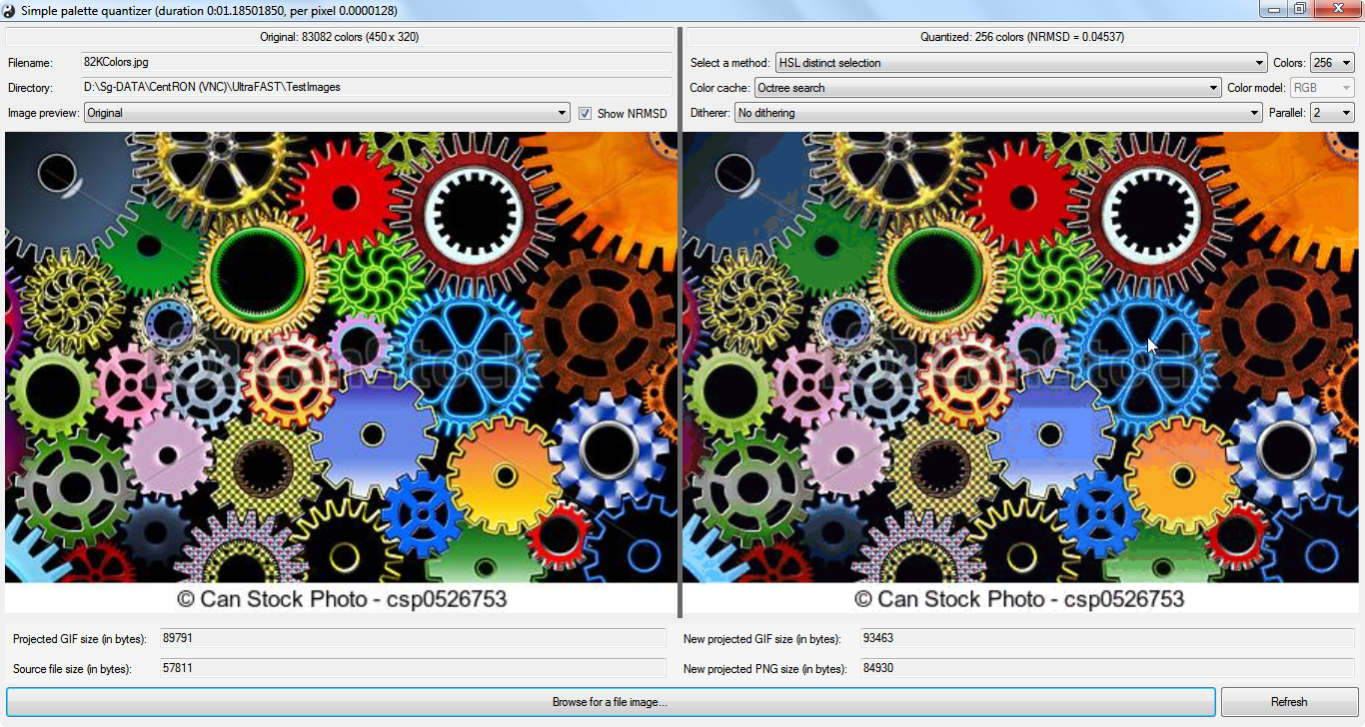

**TST18**

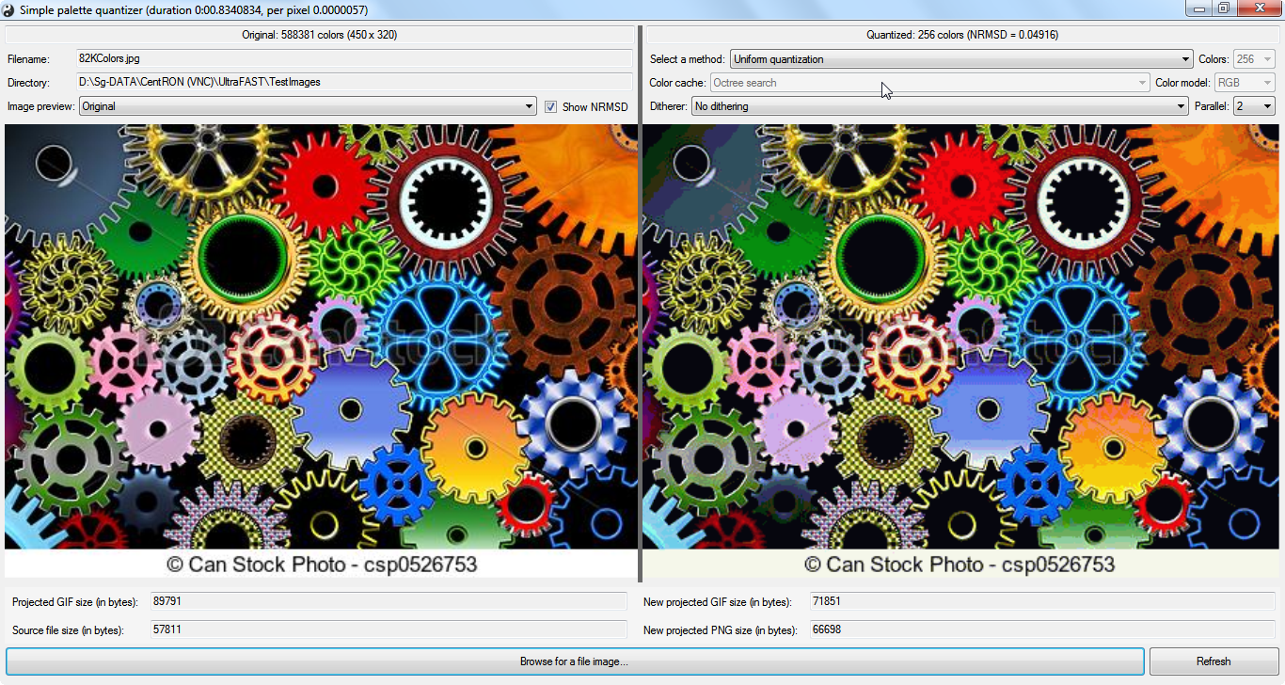

**TST19**



**TST20**

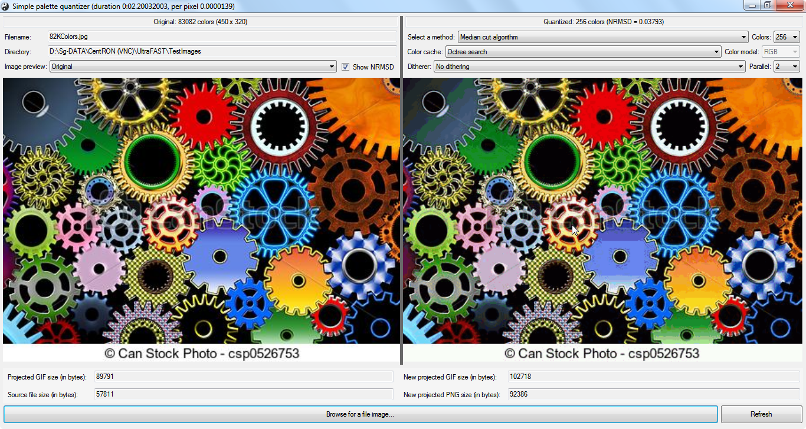

**TST21**

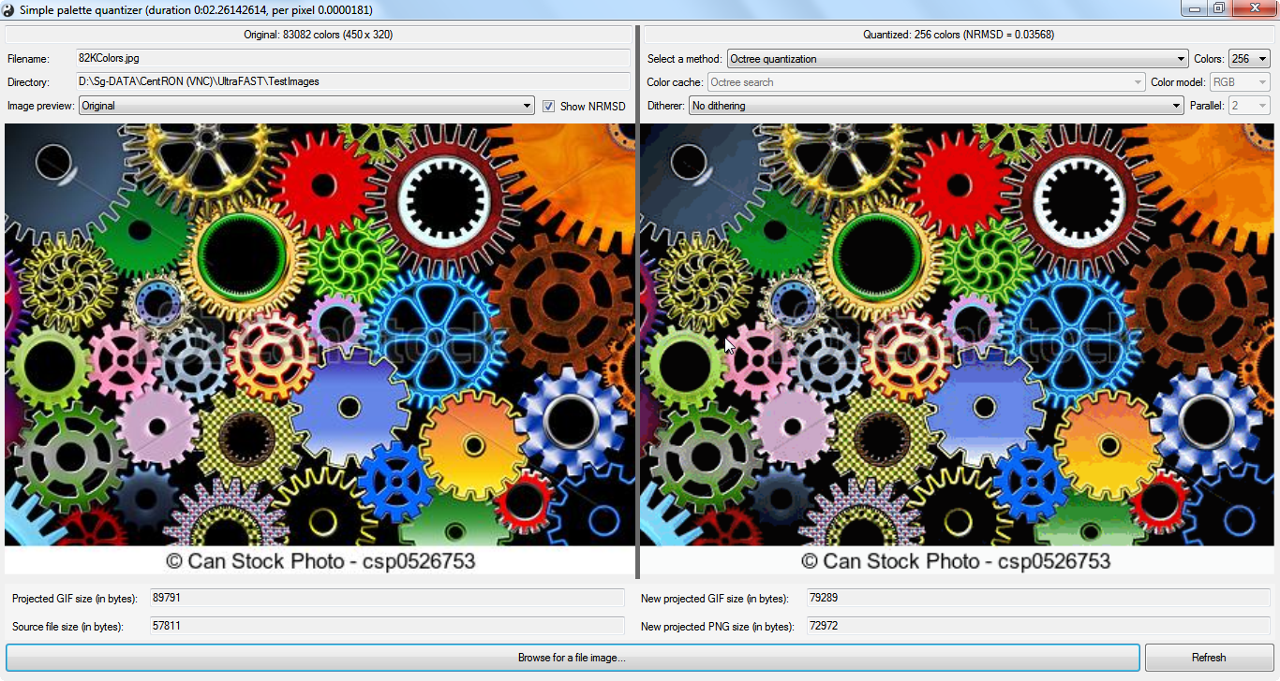

**TST22**

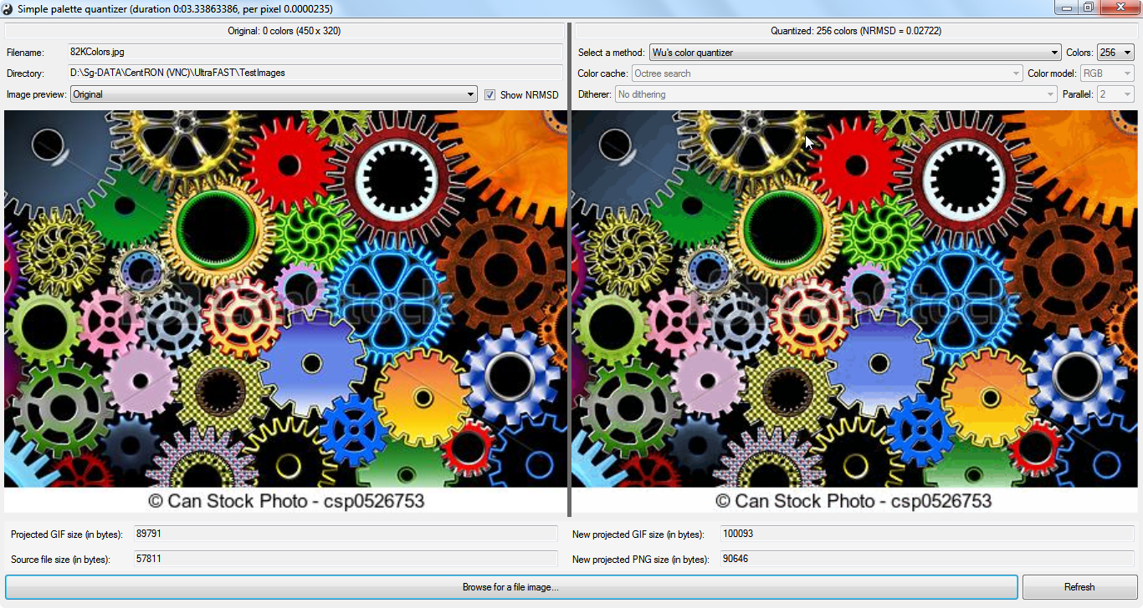

**TST23**

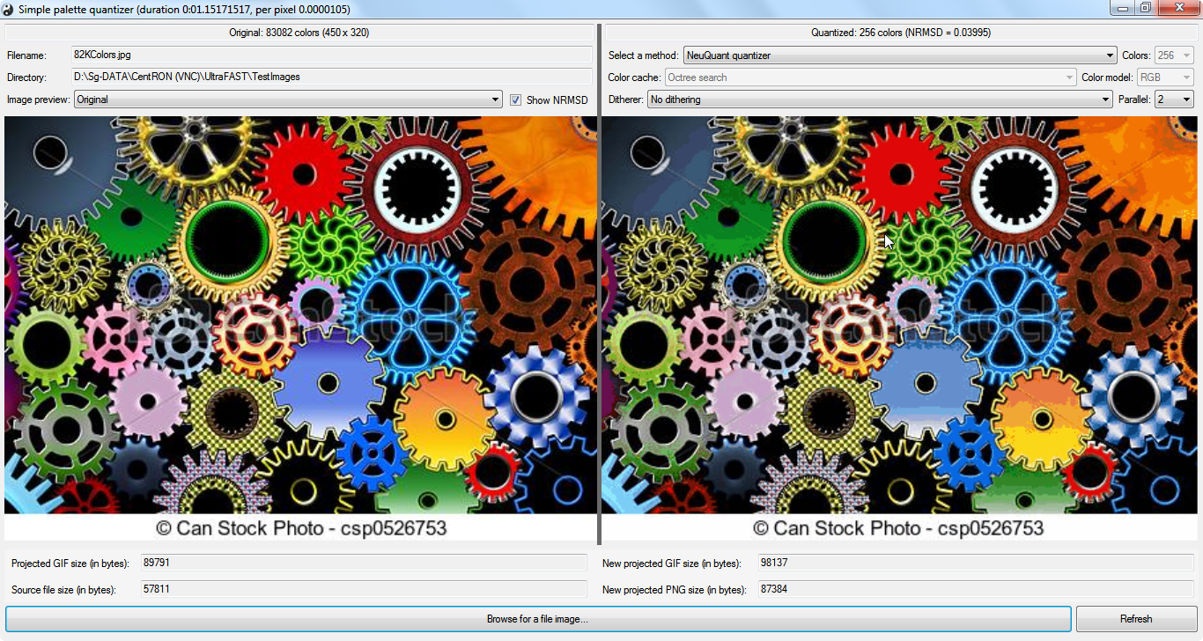

**TST24**

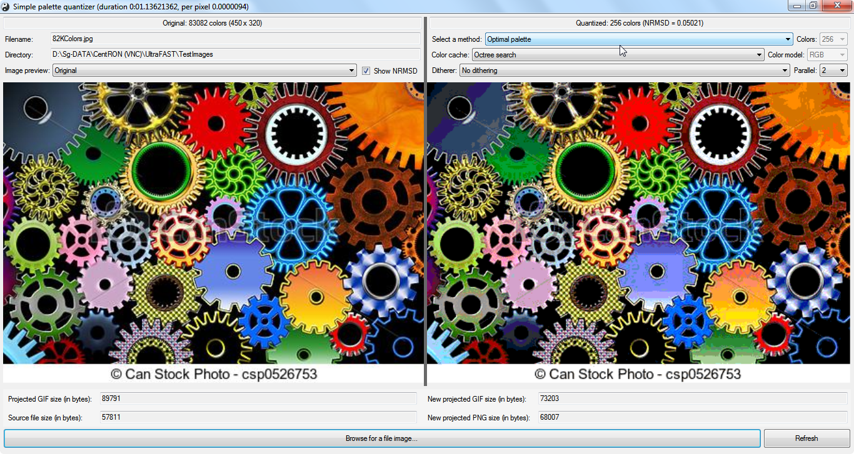

**TST25**

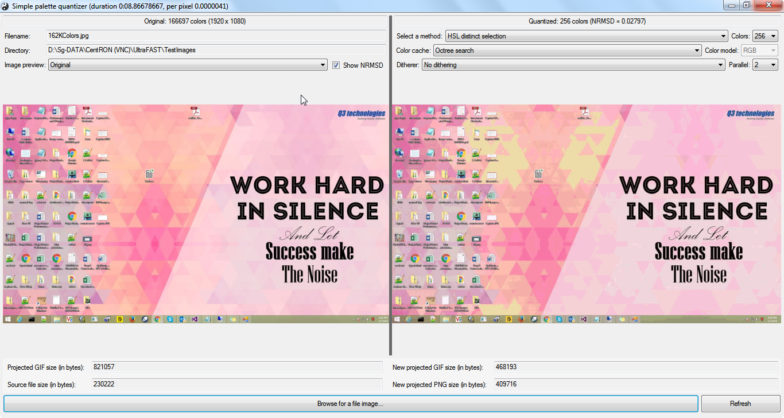

**TST26**

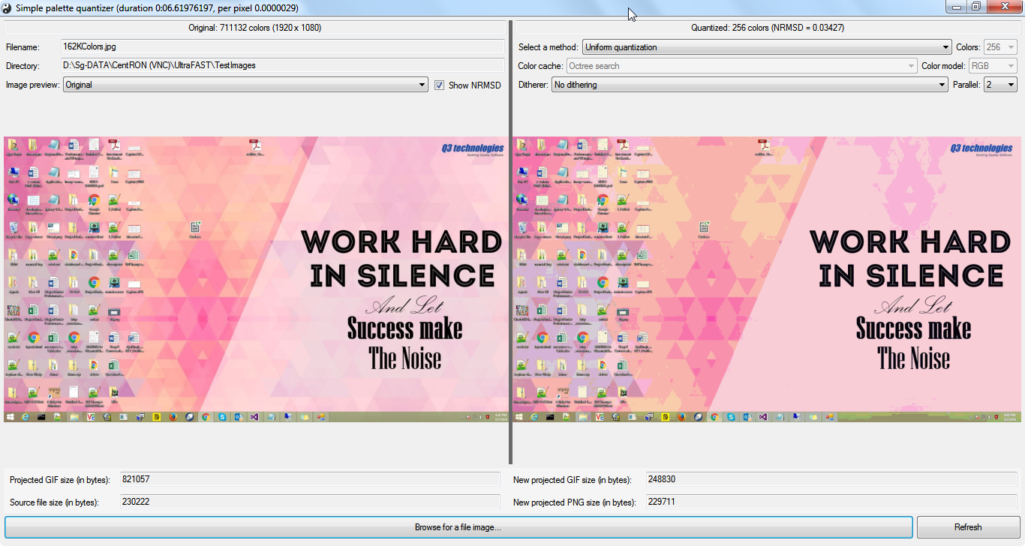

**TST27**

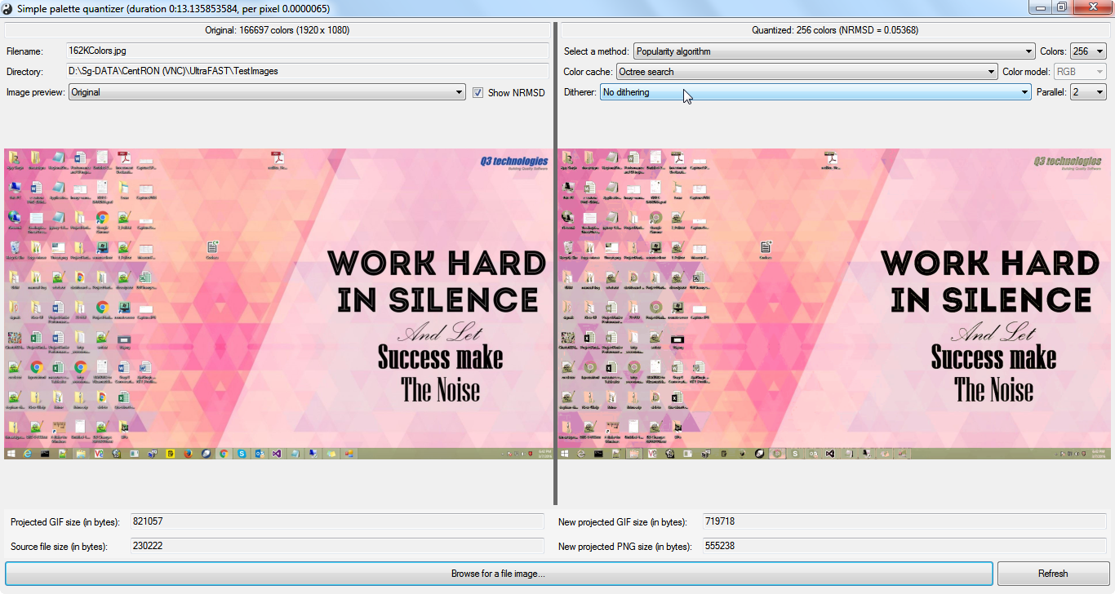

**TST28**

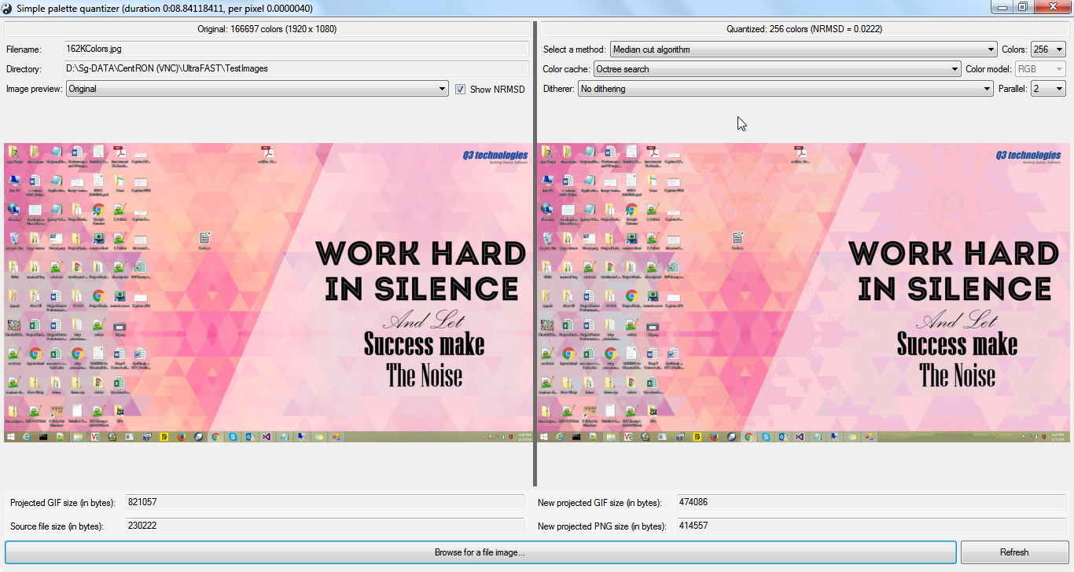

**TST29**

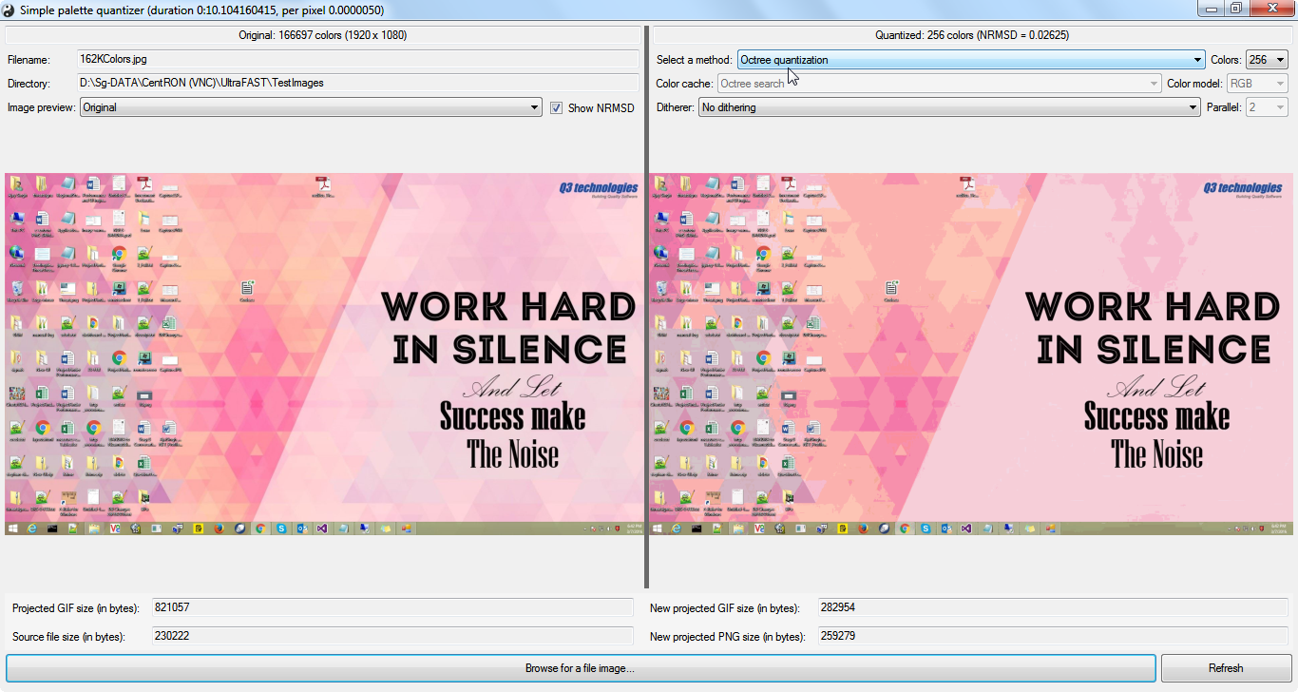

**TST30**

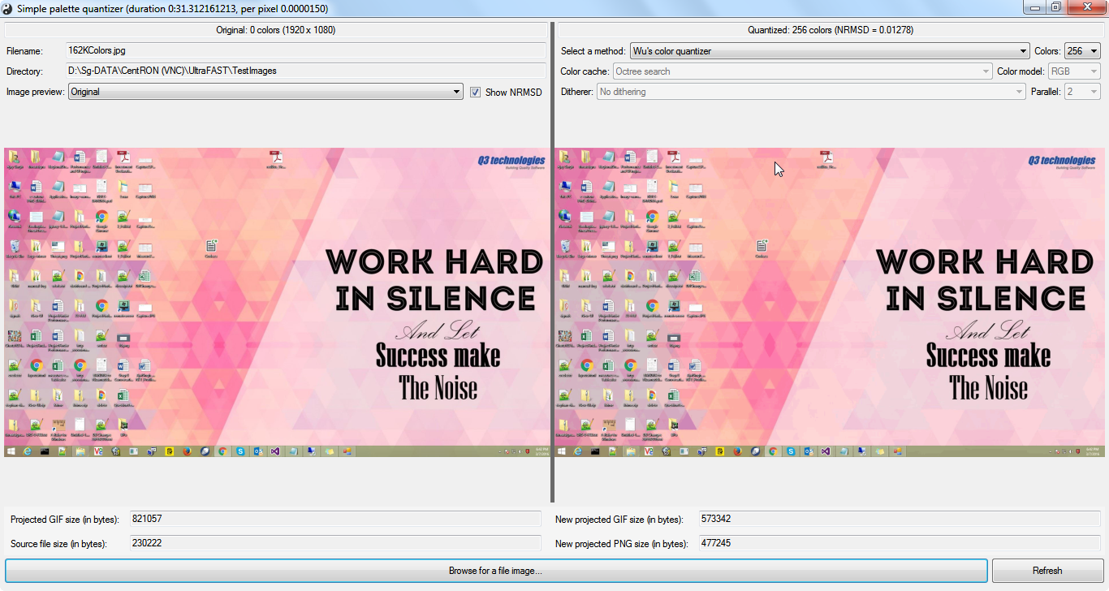

**TST31**

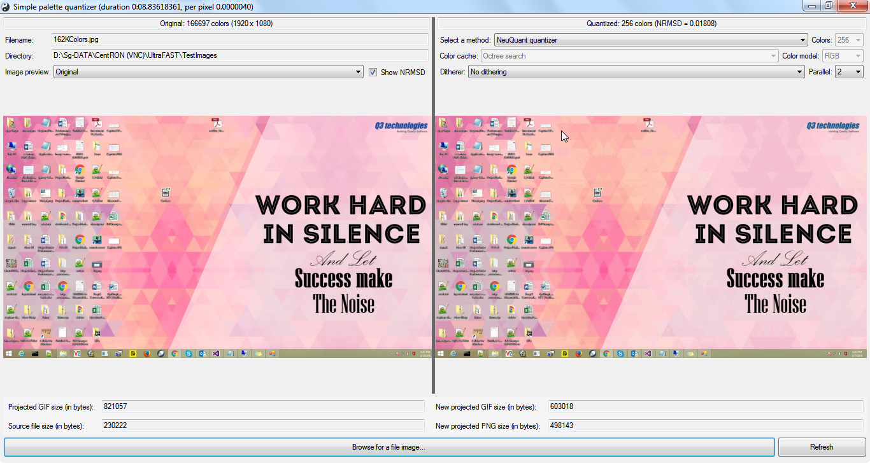

**TST32**

